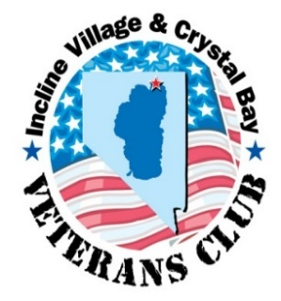

GENERAL MEMBERSHIP MEETING AGENDA

DATE: THURSDAY 29 March 2018 TIME: NOON PLACE: THE CHATEAU
CALL TO ORDER - QUORUM
PLEDGE OF ALLEGIANCE, INVOCATION, LUNCH
APPROVAL OF MINUTES- OF 22 FEBRUARY GMM MEETING

PRESIDENT’S REPORT- MARCH 29 SPEAKER DONALD STOCKTON.
VICE PRESIDENT’S REPORT – WELCOME TODAY’S SPEAKER - DONALD STOCKTON
TREASURER'S REPORT – FINANCIALS

IVGID REPRESENTATIVE'S REPORT – DUES PAID AND ROSTER UPDATE

UNFINISHED BUSINESS –
- VETERANS CLUB PLANNING A BROADWAY SHOW BY THE CARSON VALLEY COMMUNITY THEATER AND DINNER FOLLOWING AT THE CARSON VALLEY INN, SUNDAY, APRIL 29, OR SUNDAY, MAY 6 DEPENDING ON TURNOUT.
NOTE: REC CENTER WILL PROVIDE A VAN AND DRIVER TO TAKE US DOWN AND BACK.

- MEMORIAL DAY CEREMONY & SOCIAL – RAFFLE AS FUND RAISER AND PAY FOR FOOD AND DRINKS. JENNIFER WILL BE GONE, LETTIE MILLER WILL HELP WITH EVENT IMPLEMENTATION, AND WE NEED VOLUNTEERS TO HELP HER, AND THE BOARD, IN COORDINATING THIS POPULAR EVENT.

- 4th OF JULY UPDATE:
- PANCAKE BREAKFAST WILL BE ON WEDNESDAY, JULY 4TH.
- PARADE WILL BE SATURDAY, JUNE 30TH!
- RAUL CACERAS WILL BE BRINGING THE MUSTANG CLUB OF RENO, AND A VERY SPECIAL VEHICLE FOR THE PARADE, PANCAKE BREAKFAST & BEACH EVENT.
NEW BUSINESS
- DECISION ON SEPTEMBER FUND RAISER EVENT
ADJOURNMENT

